
SCI Gateway
Version 18.0 Release Notes
The purpose of these Release Notes is to highlight the changes to SCI Gateway that occur in version 18.0.

The major changes are listed on pages III to VI – What’s New in SCI Gateway version 18.0. Further details are provided on subsequent pages where appropriate.

What’s new in SCI Gateway version 18.0 for End Users
1 | User Account Locked  If you have 3 failed attempts at logging on to SCI Gateway your account will lock and you will need to see your system administrator to get your account reactivated. | 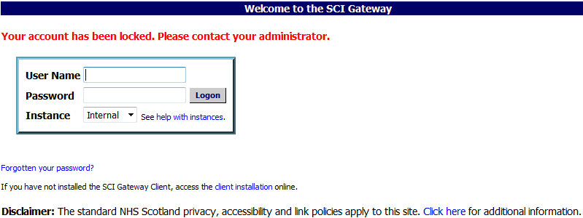
2 | Password Expiry Email Alerts  If you have an email address and security questions assigned to your user profile you will be sent email alerts when your password is due to expire. | 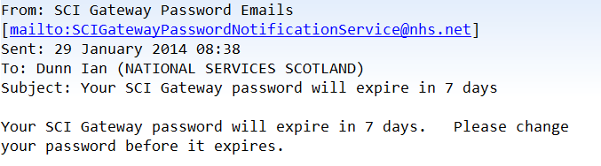
3 | Single Log In for Multiple User Accounts  Users with multiple accounts for SCI Gateway will now be able to have a single log in and select their current location from a list. | 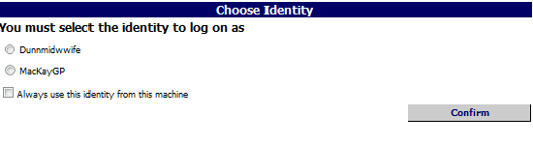
4 | Choose Message Destination By Specialty  You will now be able to choose the Specialty that you wish to send a message to prior to choosing the Location/Hospital.
5 | Branch Surgeries  It is now possible to select the branch surgery address when adding the registered and referring GP details of a patient in a protocol.
6 | Preference  You can now set a preference for the tab that is displayed on opening the worklist, e.g. if you’re a hospital receptionist you can set the worklist to open with the Receive tab displayed.
7 | Send referral from Print Preview window  You will now be able to send a message from the Print Preview window if you have the appropriate capabilities.
8 | Search Audit Trail on HEAT statuses  There are additional options in the Events option in the Audit Trail that allow you search on HEAT statuses.

What’s new in SCI Gateway version 18.0 for Admin Users

1 | Managing User Accounts  The User Maintenance option through the NHS Directory has now changed and a new Users option from the Menu Bar. This change is to facilitate a single log in for users with multiple identities. | 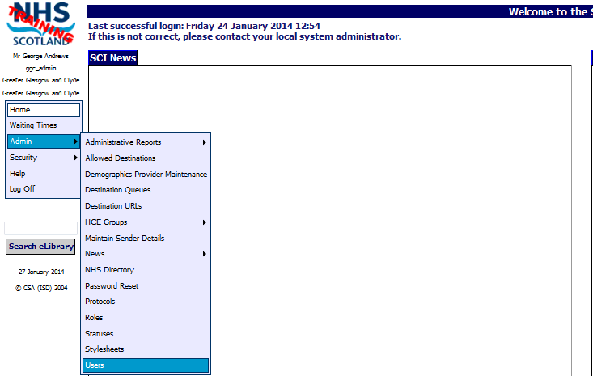
2 | Reduced Admin Account  You can create an admin user who will only be able to reset passwords. They will not be able to view any other part of SCI Gateway.
3 | User Account Locked  If a user has 3 failed attempts at logging on to SCI Gateway their account will lock and you will need to unlock it to reactivate their account.
4 | Extra - Choose Message Destination By Specialty  This new Extra, when set, will mean that users will choose the Specialty to which they send a message prior to choosing the Hospital/clinic.

5 | Extra - Send Message from Print Preview  It is now possible to configure a location to be able o Send messages from the Print Preview window by setting an Extra for the location.
6 | User Permission Summary  A new function has been added so that you can quickly view a user’s permissions from the User identity window or the Roles window.
7 | National Dental Branch  This branch has now been added to the NHS Directory. The status of the branch is “Inactive” and the HCEs within the branch will need to be configured in the same way as any other HCE. | 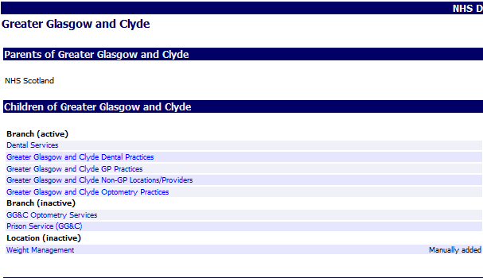
8 | SCI News  The number of characters for National and Local News items displayed on the SCI Gateway Home screen has been increased from 500 characters to 1000 characters.

End User Changes

User Account Locked
If you have three failed login attempts your account will now be locked and you will have to contact your system administrator to get your account unlocked and password reset if required. Pictured below is the message displayed after 3 failed attempts to login to SCI:

Once your account has been unlocked by your system administrator you can log on to SCI Gateway as usual. Pictured below is an example of what will be displayed after your account is unlocked:

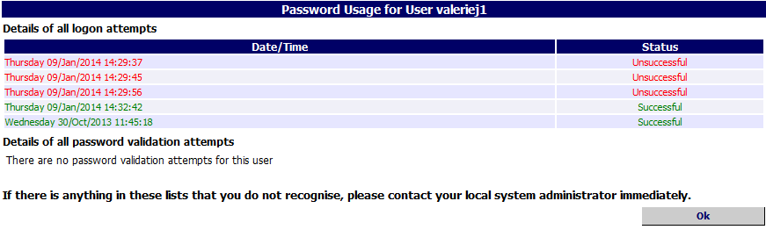
Click on OK to continue

If you do not recognise any of the failed login attempts as being carried out by you, you should alert your system administrator immediately.

Unlocking your account will enforce a password re-set. When you click on Ok as shown above, you will be returned to the login window and you must change your password before you can log on.

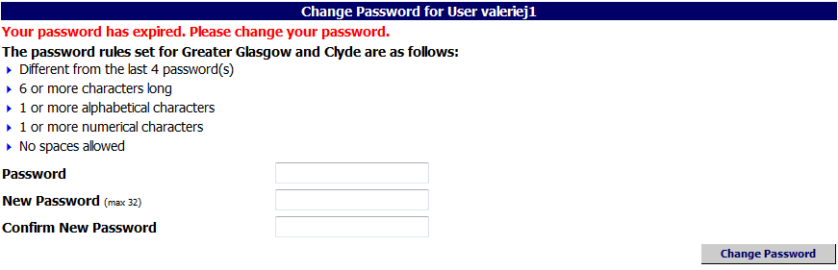
Enter current Password and enter new password in New Password and Confirm New Password
Click on Change Password

Password Expiry Email Alerts
Currently passwords in SCI Gateway are configured to expire after 90 days. Messages indicating the countdown to the expiry date are displayed when you log on from seven days prior to that date. A change has been made and if you have security questions and an email address configured on your user account you will be notified by email that your password is due to expire. Pictured below is an example of the email you would receive seven days prior to your password expiring:

When you receive an email like the one displayed above you should change your password at the earliest opportunity. When you log on to SCI Gateway click on Security|Change Password on the Menu Bar:

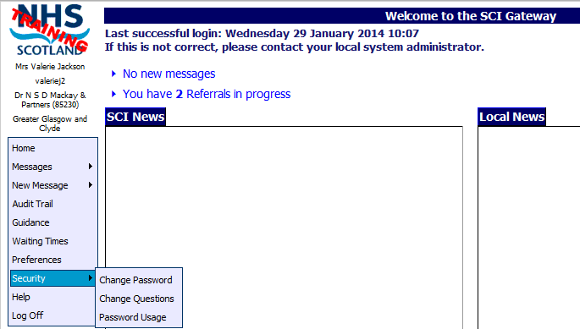
Point to Security and click on Change Password

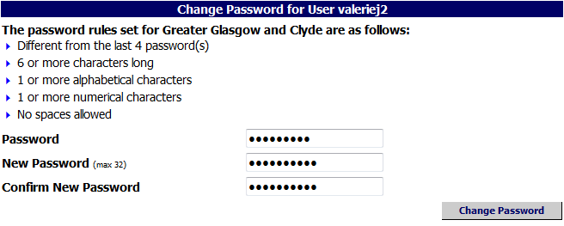
Enter current Password and enter new password in New Password and Confirm New Password
Click on Change Password
Pictured below is the confirmation message saying your password was successfully changed, which is displayed after clicking on Change Password as described on the previous page:

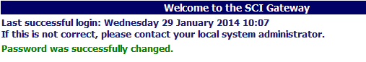

Forgotten passwords
If you have forgotten your password click on the link at the log in window:

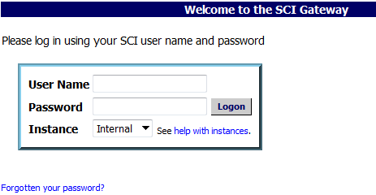
Click on Forgotten your password?

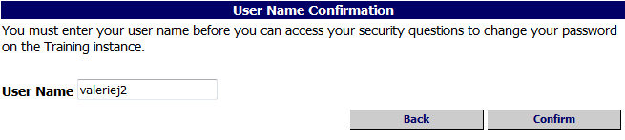
Click on Confirm
Enter your username here

You will be sent an email with a link to allow you to change your password:

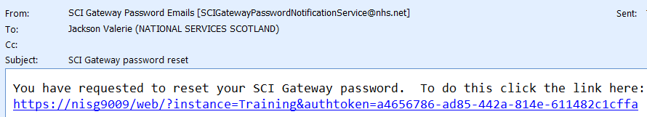
Click on the link

Pictured below is the Security Questions Confirmation window displayed after clicking on the link in the email received from SCI Gateway:

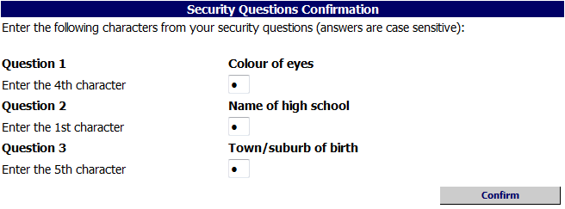
Enter the appropriate letters to answer the security questions
Click on Confirm

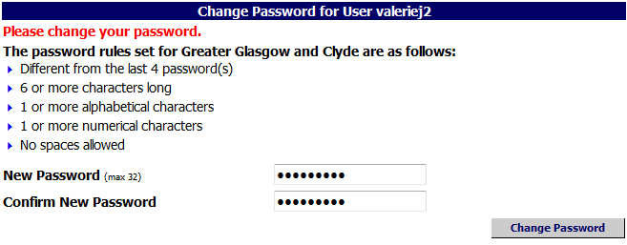
Enter a new password in New Password and Confirm New Password
Click on Change Password

When you have reset your password you will receive an email confirming your password has been reset:

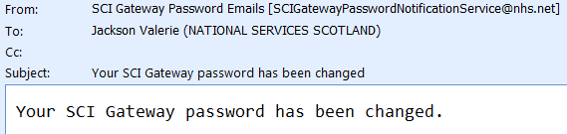

- An email will be sent on each of 14, 7, 2 and 1 days prior to your password expiring. You should change your password at the earliest opportunity.
If you receive a link in the email to reset your password the link is only valid for 2 days. If you attempt to reset from the link on the third day a message will be displayed saying:
‘The account reset request has expired. Please try again or contact your administrator.’
There is a 21 day grace period following the 90 day password expiry date. You can still reset your password during this period. If you try to reset your password after this grace period a message will be displayed saying:
‘Your password has expired. Please contact your administrator.’

Single Log In for Multiple User Accounts
Some SCI Gateway users work at a number of different locations necessitating a separate user account for each location. New functionality will allow these users to have a single log in and then select the location where they are working. Log on to SCI Gateway in your usual way and if you have more than one identity assigned to your account the Choose Identity window will be displayed:

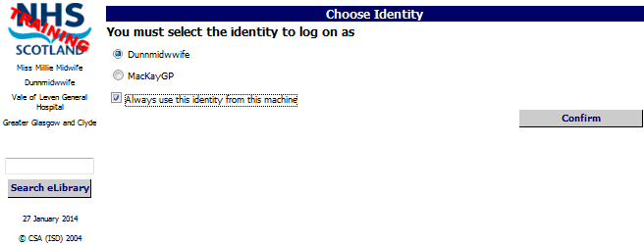
Select the Identity for the location by clicking on the appropriate radial button
Tick ‘Always use this identity from this machine’ box if this is your usual workstation at this location
Click on Confirm

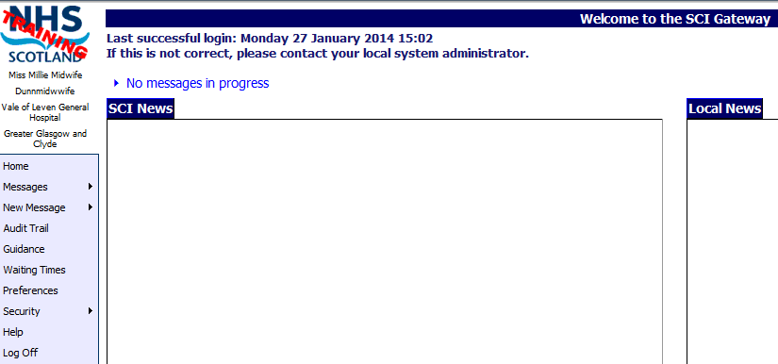

After clicking on Confirm as shown above you are returned to the Home page where you can create, send and manage messages as usual.

Always use this identity from this machine
If you select the ‘Always remember this identity on this machine’ tick box as shown on the previous page, when you log on to SCI Gateway your identity will be remembered and you will not be asked to select your identity again when using that specific computer unless your account login expires or is deleted.

Preferences
If you do not select ‘Always use this identity from this machine’ when you log on at a specific computer you can set your user defaults at a later time using Preferences. On the SCI Gateway Menu bar click on Preferences:

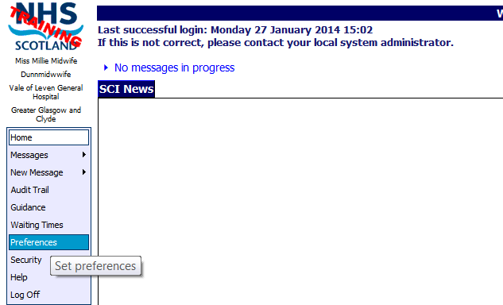
Click on Preferences

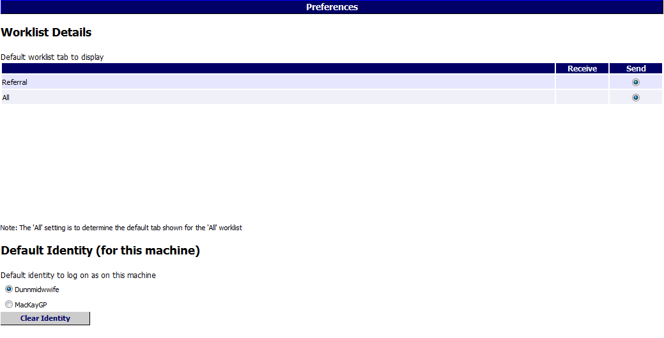
Select Default Identity to be used at this machine
Click here to clear all settings
Click on Save to save your identity setting

- Single login for multiple identities does not have any impact on users who only ever work from one location. You will continue manage messages as usual.
See page 1-10 for more information on setting other preferences as shown on Preference window above.
Choose Message Destination by Specialty
New functionality has been added to SCI Gateway and if applied will change your message destination options order. You will choose the specialty option prior to the location option. Log on to SCI in the usual way:

Point to New Message and click on Referral

Specialty before Location

- If you have any questions about the order of your destination options please see your local system administrator.

Branch Surgery
If your GP surgery has a branch surgery you will now be able to select the branch address in protocols if that is your patient’s usual location for seeing the GP. In the protocol click on the Administration tab:

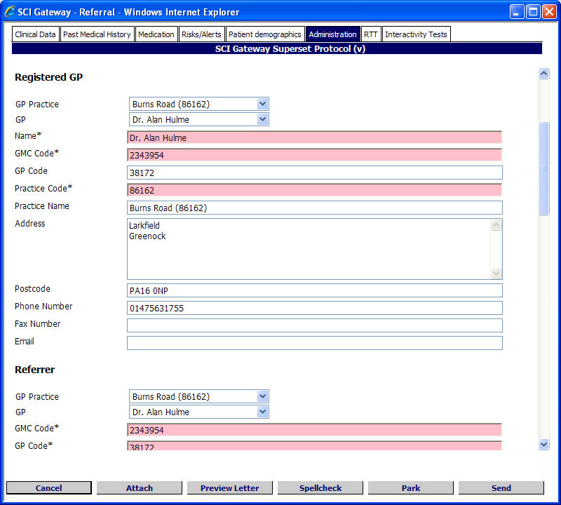
Select the branch surgery address from the drop down list

Select the Registered GP
Select the branch surgery address from the drop down list

Select the Registered GP

- Once you have selected the branch details the address will be populated in the protocol. Complete the protocol and send in the usual manner.
In the protocol shown above the GP detail questions are in the Administration tab. If you have different local protocols the GP details maybe displayed on a different tab.
If you have any questions relating to protocols please contact your local system administrator.

Preferences
Previously, if you had the ability to both send and receive messages the worklist opened with the Send tab displayed. If you predominantly received messages this was inconvenient. You can now set the worklist to open in your preferred tab depending on the worklist that you open. For example, if you are opening the referrals worklist you can set the preference option to open with the Receive tab displayed. From the SCI Gateway Home page click on Preferences on the Menu bar to set your personal worklist preferences:

Click on Preferences

Click on the options required - in this instance receive referral
Click on Save

If you send and receive referrals as in the example above the ‘Send’ option will be ticked by default which will display the Send tab on the referral worklist. You need to select the ‘Receive’ option to display the Receive tab when you open the worklist.

Pictured below is a referrals worklist displayed after selecting Messages|Referrals. The Receive tab is to the fore after setting the referral worklist to ‘Receive’ as described on the previous page:

Receive tab displayed to the fore

Default Message Settings
Pictured below are the default settings for all message types and can be changed to suit your own requirements:

- If you have any questions relating to preference settings and or other message types please see your system administrator.

Send Message from Print Preview
You will now be able to send a message from viewing the letter in the print preview window. In this instance we are using a referral letter. From the Protocol click on the Preview Letter button at the bottom of your screen:

Click on Preview Letter

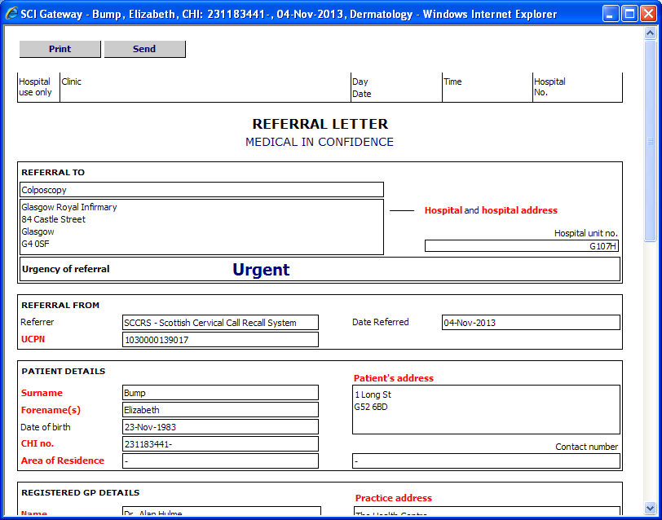
Click on Send to send the message

After clicking on Send as shown above, the usual links to missing mandatory information and confirmation messages will be displayed. Proceed as usual until your message is sent and you are returned to the worklist where your message will have a status of ‘Submitted’.

System Administrator Changes

Managing Users Accounts
In order to facilitate allowing users with multiple identities to have a single log on to SCI Gateway there have been significant changes made to adding and managing users in the NHS Directory tree. There is a new Users option on the Menu Bar. To add a new user point to Admin and select Users:

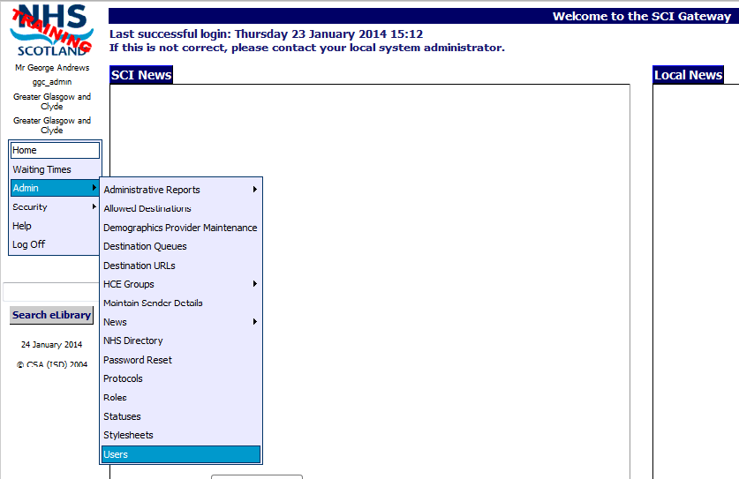
1 Point to Admin and select Users

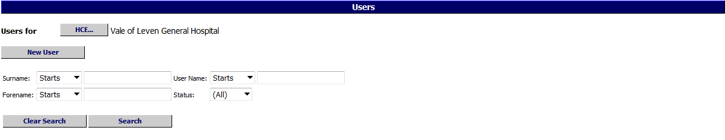
2 Select location to add user from the NHS directory by clicking on HCE..
3 Click on New User

- Users can be managed from this window using the search fields. See page 2-6 for information on how to edit a user or add a new identity to a user.

Pictured below is the New User window displayed after clicking the New User button as described on the previous page:
4 Select Title from drop down list

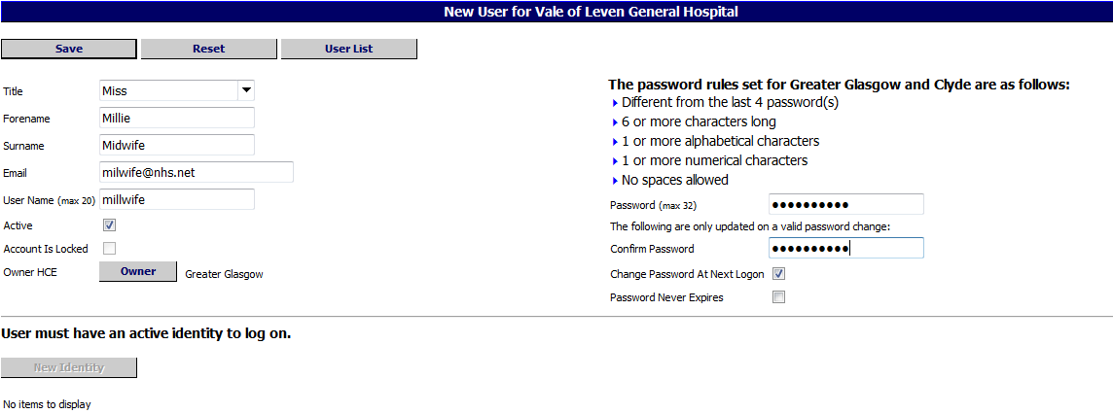
8 Click on Save
5 Enter Forename Surname, email address and Username
6 Select an Owner – usually the health board
7 Enter a Password and Confirm Password

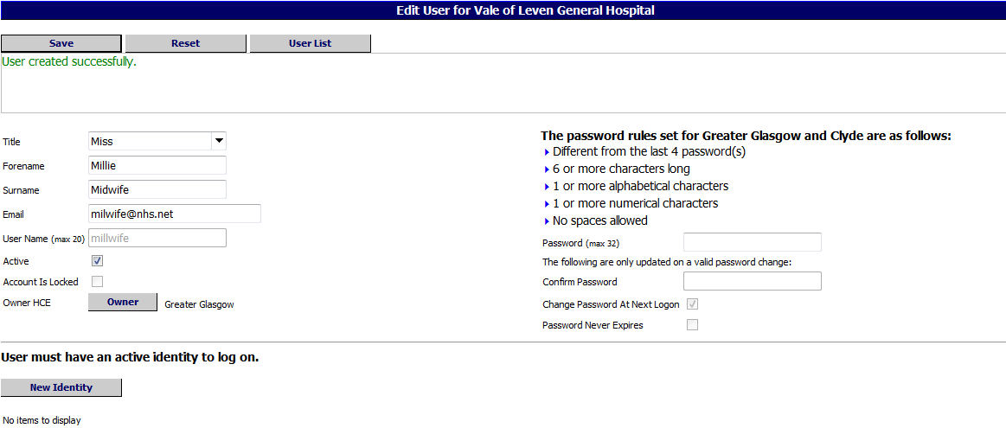
Confirmation message saying User created successfully
9 Click on the New Identity to complete the profile

Pictured below is the New Identity window displayed after clicking on the New Identity button as described on the previous page:

10 Enter a name for this identity, i.e. identifies the location at which it is used
11 If the same contact email is used tick the box. Alternatively enter a new contact email
13 Select one or more roles to assign to the profile from the list and click on Add
12 Select a Home location from the NHS directory

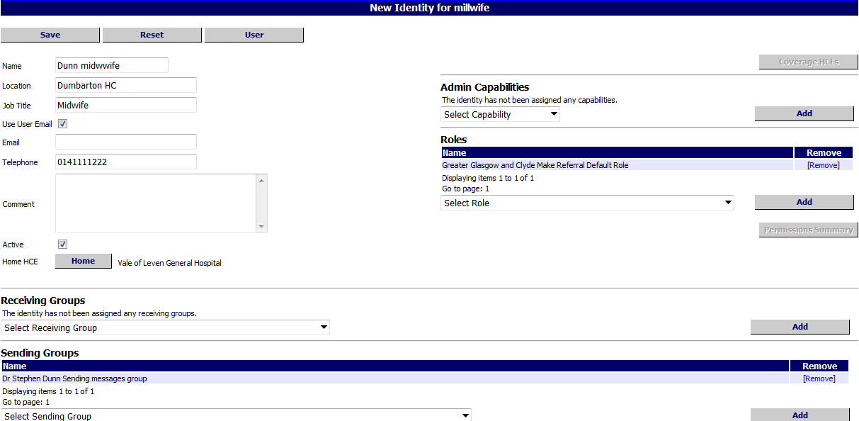
14 Select a Sending and/or Receiving group from the drop down lists and click on Add
15 Click on Save to save the identity

16 Click on User to return to Edit User window if you need to add another identity
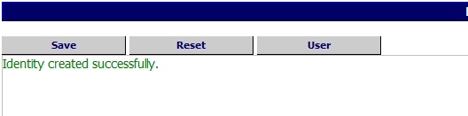
Confirmation message displayed

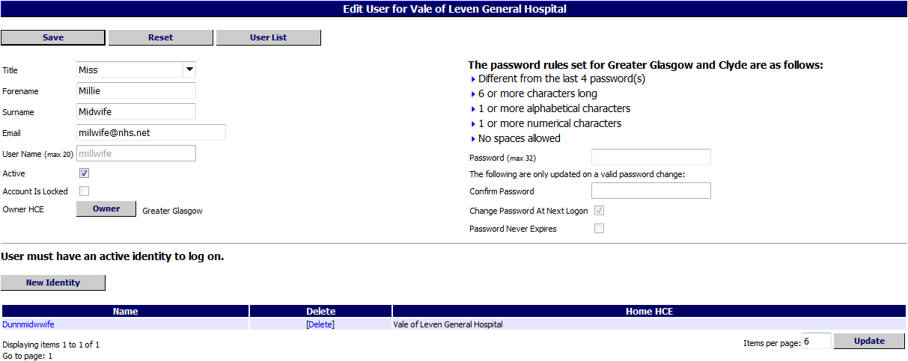
New Identity displayed here
17 To add another identity click on New Identity and follow steps 10 - 16

- The User window is displayed at the HCE level of the logged on user. For example, if the user is a health board administrator the page displayed will be at the health board level. The users will be displayed in a list which can be filtered by clicking on the HCE button which will open the NHS directory tree. You can then select the required HCE.
Users will now have an Owner in the same way as protocols, stylesheets and sending and receiving groups.
Admin users can be added in the same way but you must add Admin Capabilities from the drop down lists and click on Add.

Adding a new identity to an existing user
To assign an additional identity to a user navigate to the User’s window as described on page 2-1 and search for your user:

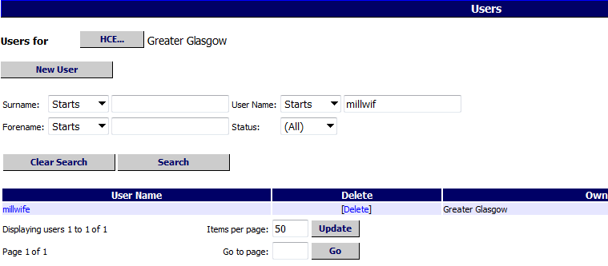
1 Find for your user using the required search criteria

2 Click on Search

3 Click on the Username

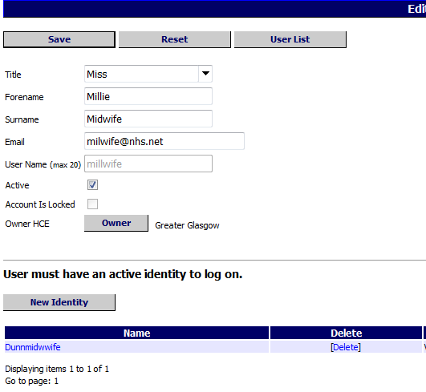
4 Click on New Identity button

Pictured below is the New Identity window displayed after clicking on the New Identity button as described on the previous page:
5 Enter a name for this identity, the location at which it is used
6 If the same contact email is used tick the box. Alternatively enter a new contact email
8 Select one or more roles to assign to the identity from the list and click on Add
7 Select a Home location from the NHS directory

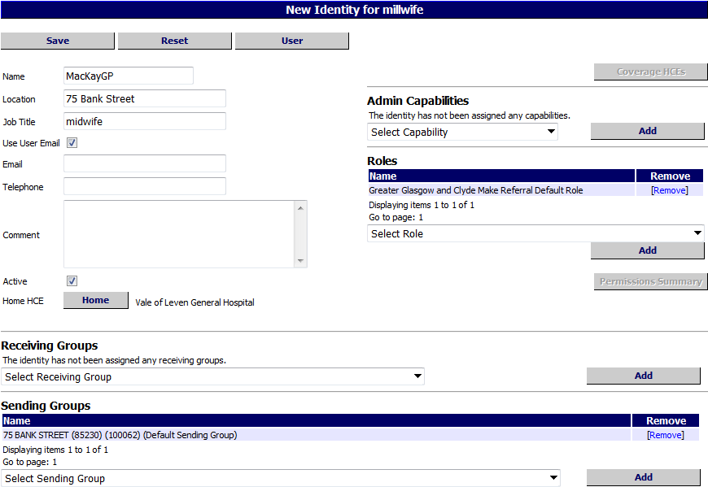
9 Select a Sending and/or Receiving group from the drop down lists and click on Add
10 Click on Save to save the identity

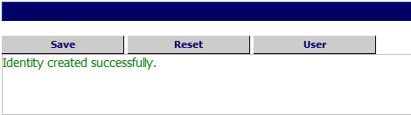
11 Click on User to return to Edit User window
Confirmation message displayed

User Permission Summary
If you need to know the breadth of a user’s permissions via the roles that they have been allocated there is new option that will allow you to do this. Navigate to the user using the new Users option from the Menu bar:

Point to Admin and click on Users

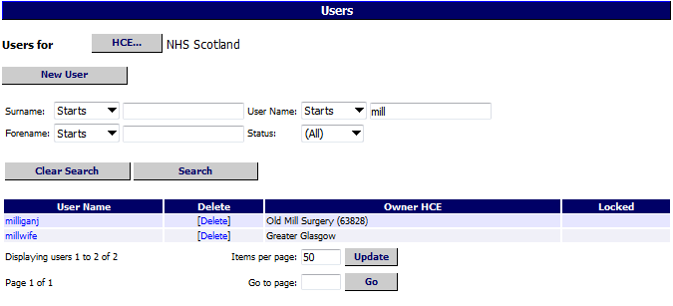
Search for the user required using your preferred search fields
Click on the username

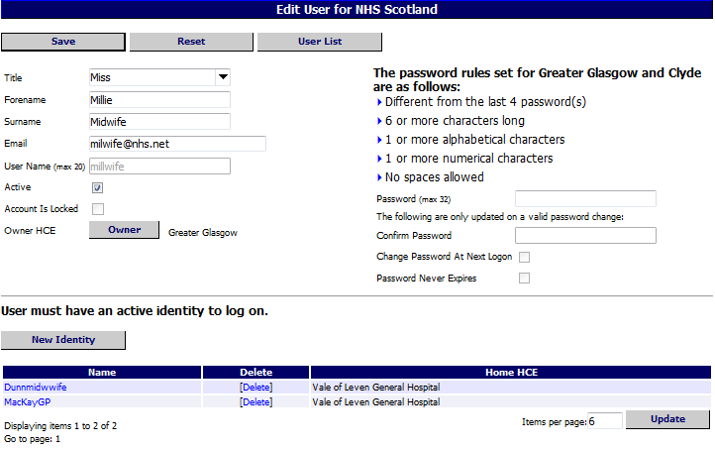
Click on the required identity name

Pictured below is the Edit Identity window displayed after clicking on the user’s identity name as described on the previous page:

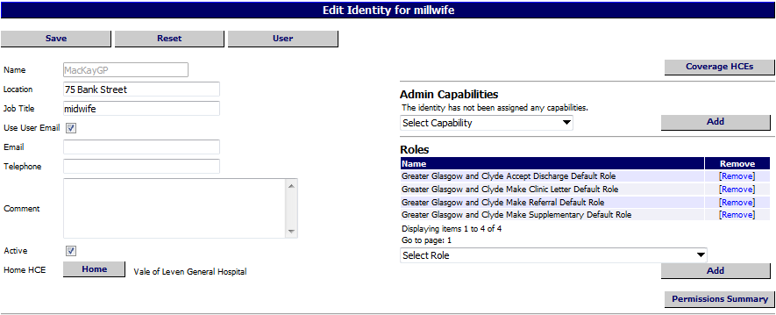

Click on Permission Summary

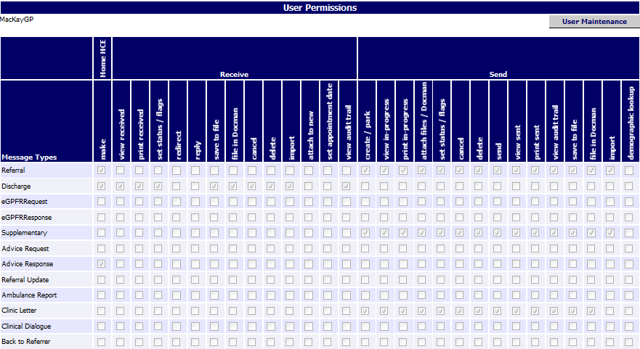
Users’ permissions are displayed here

Viewing User Permission Summary from Roles
The same information can be viewed using the Roles functionality. Point to Admin and click on Roles in the Menu bar:

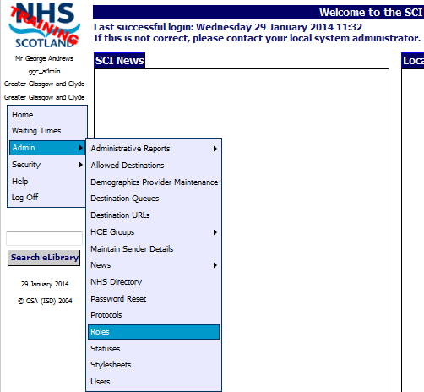
Point to Admin and click on Roles

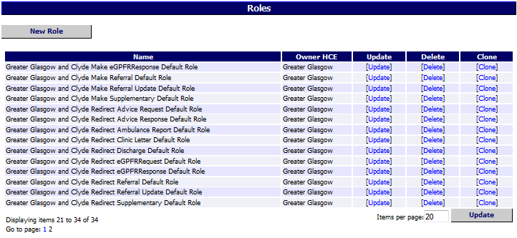
Click on [Update] next the role you want to view

After clicking on [Update] as described on the previous page the Edit Roles Details window is displayed. The bottom half of the window, pictured below, shows the list of the User identities in Roles. Click on Permission Summary at the bottom of the window:

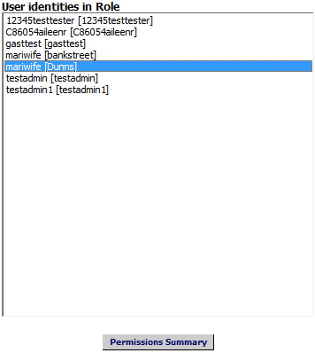
Click on Permission summary

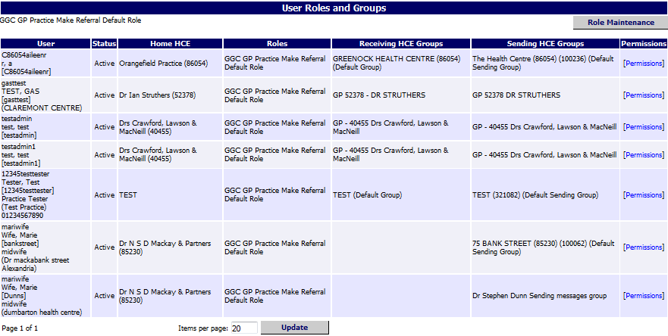
Click on [Permission]

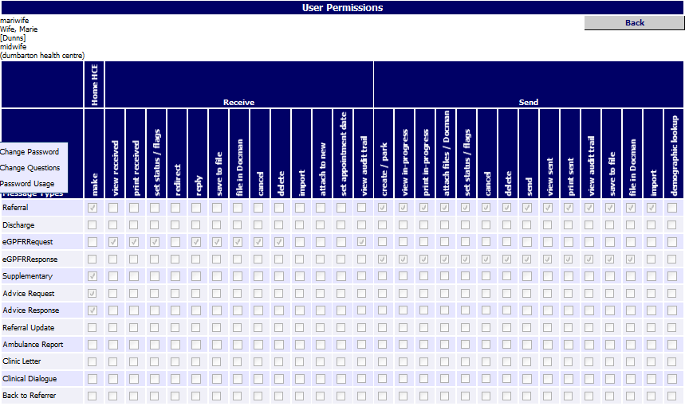
Details displayed here

Extra - Choose Message Destination by Specialty
There is a new Extra which when set will allow users to choose Specialty prior to Location when selecting their message destination options. This Extra can only be applied at health board level. Navigate to the required health board in the NHS Directory tree and scroll down to the Extras section. In this instance Greater Glasgow and Clyde has been selected:

Click on Add Extra

Select ‘Choose specialty before location’ from drop down list
Select ‘Yes’ from the drop down list
Click on Save

After clicking on Save you are returned to the NHS Directory tree and the Extra has been added to the list as displayed below:

Newly added Extra displayed here

When selecting their destination options for a message users in that health board will now select the specialty prior to the location for sending messages.

For more information on how this functionality will apply to end users see page 1-8.

Extra - Send Message from Print Preview Window
There is a new Extra which when set will allow users to send a message from the print preview window. This Extra can be added to an individual location or at a higher level if required. Navigate to the location you want to add the Extra in the NHS Directory window. In this example it is being added at GG&C GP practices:

Click on Add Extra

Select Submit Referral From Preview, Yes and Referral from the drop down lists
Click on Save

New Extra added here
- For more information on how end users will be able to apply this functionality see page 1-12.
In the example above the Extra has been added for referrals. At this time it cannot be added for any other message type.

Restricted Admin User
There is a new admin capability which when applied will allow an admin user to be able to reset users’ passwords when required. This capability will not allow them to carry out any other functions on SCI Gateway. To assign this capability navigate to the location in the NHS directory where you want the admin user to have coverage. In the following example the new admin user is being added at health board level so there is no need to navigate to another HCE lower in the NHS Directory.

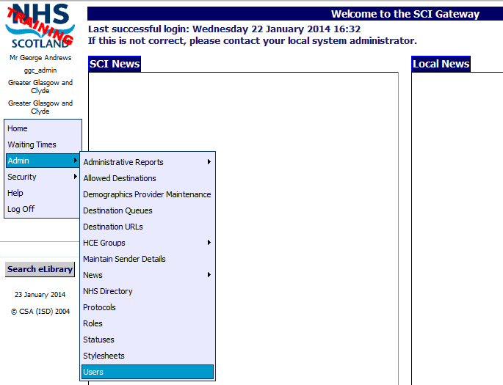
1 Point to Admin and select User

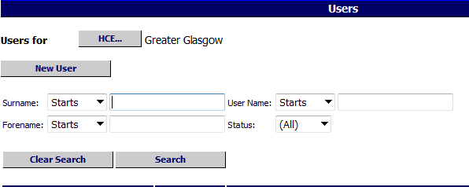
2 Click on New User

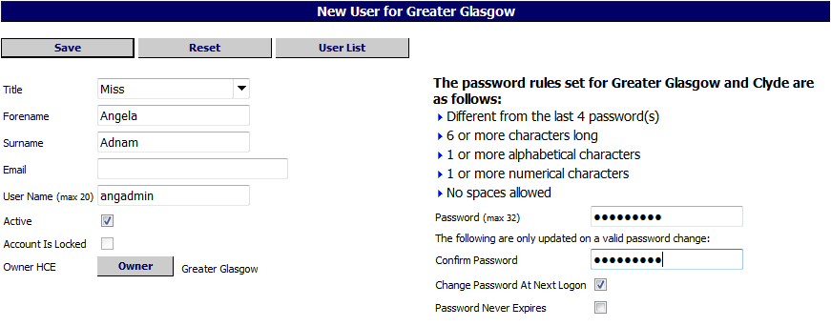
3 Enter details in to Title Forename, Surname, Email and Username
5 Click on Active when ready to activate
4 Select an Owner from the list – usually the health board
6 Enter details in to Password and Confirm Password
7 Click on Save

Pictured below is the Edit User window with the confirmation message, saying the user has been successfully created, displayed after clicking on Save as described on the previous page:

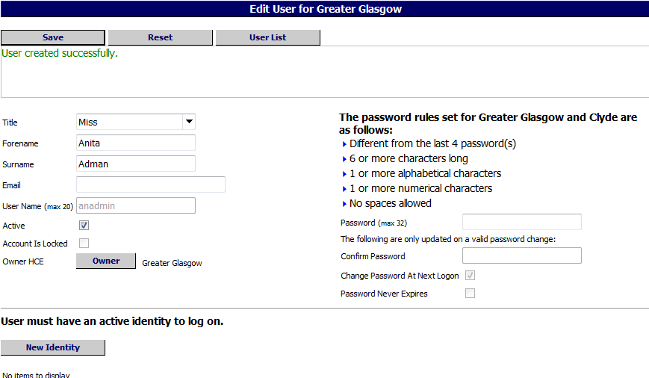
8 Click on New Identity
9 Enter a Name, location and Job Title
Confirmation message displayed here

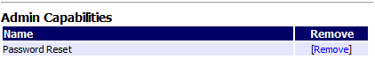
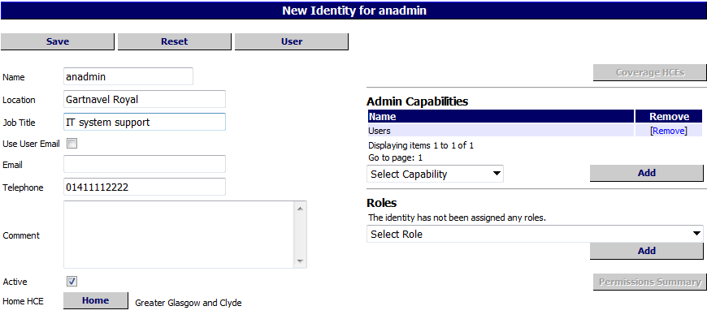
10 Contact details required for password expiry - email address or telephone number
11 Select Password Reset and click on Add
12 Click on Save

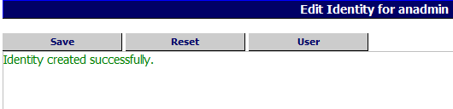
Message is displayed confirming Identity successfully created

Using Password Reset
The admin user with the restricted capabilities can now log in to SCI Gateway and reset passwords when requested. In this instance we will reset user valeriej2’s password.

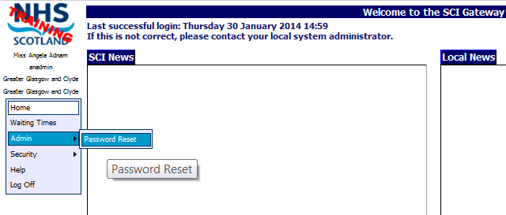
Point to Admin and click on Password Reset

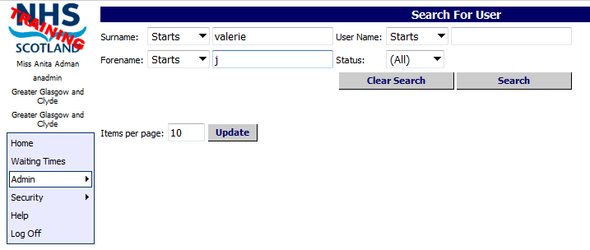
Enter Surname and Forename
Alternatively enter all or part of the username
Click on Search

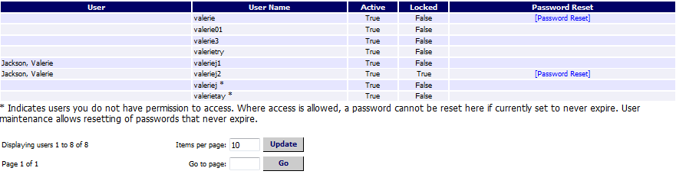
Click on [Password Reset] beside the required user

Pictured below is the Reset Password window displayed after clicking on [Password Reset] link as described on the previous page:

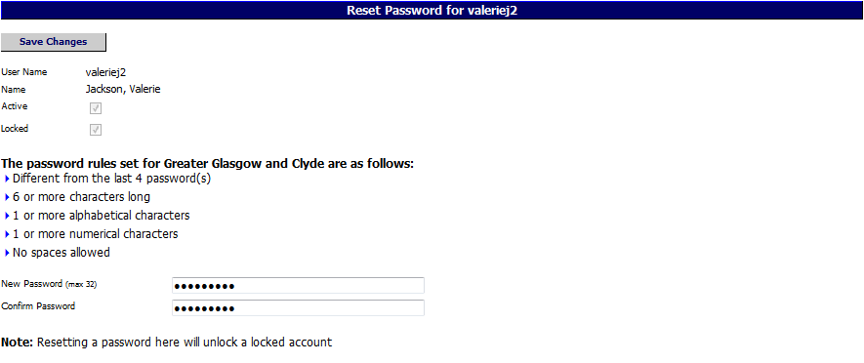
Enter details in to Password and Confirm Password
Click here to remove tick from Locked box
Click on Save

- If an admin user has restricted access with ‘Reset password’ capability only they will not see the [Unlock] link that an admin user with the capability of Users will see. To unlock a user’s account they must reset the user’s password.

User Account Locked
If a user has three failed login attempts their account will now be locked and they will have to contact their system administrator to get the account unlocked and password reset if required. There is a new link which will allow you to do this quickly. Point to Admin and select Users:

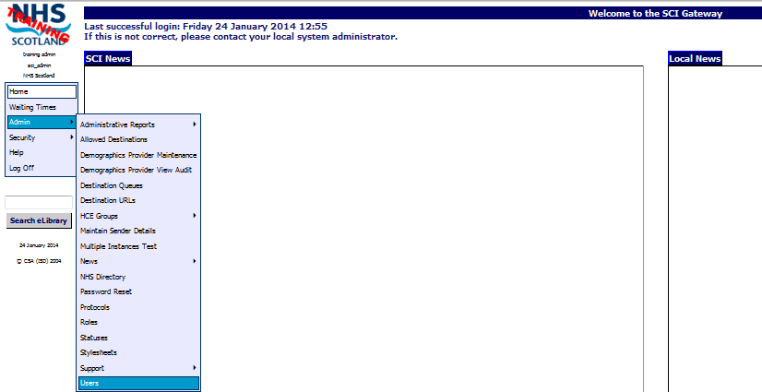
Point to Admin and select Users

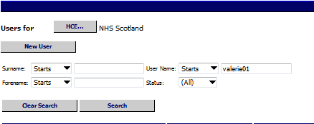
Enter username here. Alternatively use Forename and Surname fields
Click on Search

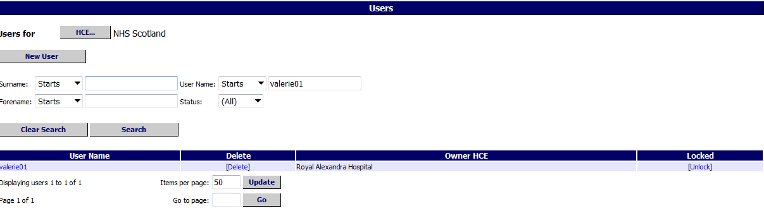
Click on the [Unlock] link next to the user’s name

The [Unlock] link is removed from the user’s account. There is no confirmation message and no need to reset the user’s password if the lock out was a result of a key stroke error.

If the lock out is a result of the user forgetting their password, you will also need to reset the user’s password.

Alternatively, you can reset the password and unlock the account at the same time by clicking on the username and opening the Reset Password window and following the steps described on page 2-17.

National Dental Branch
The national Dental branch has been added to the NHS Directory through the ISD reference files. In order for dentists to send messages through SCI Gateway their HCEs will need to be configured in the same way as any other HCE.

Users will have to be added with the appropriate roles and groups assigned. The HCE will need to be activated, have capabilities for the relevant message type and any appropriate extras and destination URLs configured e.g. CHI matching / look up.

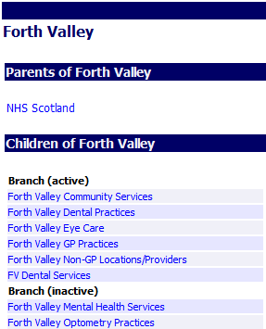
Click on the branch to expand, and activate and configure as required

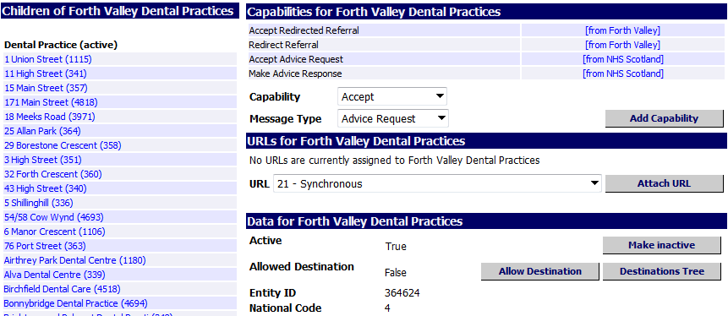
Click on the Dental practice name to open

The process for adding Dentists to the NHS Directory will be dealt with in a similar way to GPs i.e. individual Dentists need to be registered with their local health board before they can be included in the NHS Directory. Once they are included they need to be activated and assigned usernames in the same way as you would a GP.

If you require any assistance in activating and configuring the Dental branch contact the Customer Service Desk.
Maintain Sender option should not be used to add a dentist or edit the details of a Dental practice now that the practices are a core branch of the NHS Directory. These actions would result in overwriting all the practice details.

